**Software Requirement Specifications**

**Integrated Aquaculture-Agriculture Soil Enrichment System (IAASES)**

**Aabi Zaraat**

# Version: 1.0

|  |  |
| --- | --- |
| Project Code | F23-163B |
| Supervisor | Miss Sania Urooj |
| Co-Supervisor | Dr. M Farrukh Shahid |
| Project Team | Muhammad Fahad (20K-0441)  Aun Ali (20K-0286)  Mudabbir (20K-0273) |
| Submission Date | December 10, 2023 |

# Document History

*[Revision history will be maintained to keep track of changes done by anyone in the document.]*

|  |  |  |  |
| --- | --- | --- | --- |
| **Version** | **Name of Person** | **Date** | **Description of change** |
| 1.0 | Muhammad Fahad | November 24, 2023 | Document Created |
| 1.0 | Muhammad Fahad | November 24, 2023 | Added Introduction |
| 1.0 | Muhammad Fahad | November 26, 2023 | Added Design Considerations |
| 1.0 | Muhammad Fahad | December 07, 2023 | Added Activity Diagram and Component Diagram |
| 1.0 | Muhammad Mudabbir | December 07, 2023 | Added Sequence Diagram and State Machine Diagram |
| 1.0 | Muhammad Mudabbir | December 09, 2023 | Added Design Strategy |
|  |  |  |  |

# Distribution List

|  |  |  |
| --- | --- | --- |
| **Name** | **Role** | |
| Miss Sania Urooj | | Supervisor |
| Dr. M Farrukh Shahid | | Co-Supervisor |
|  | |  |

# Document Sign-Off

|  |  |  |
| --- | --- | --- |
| **Version** | **Sign-off Authority** | **Sign-off Date** |
| 1.00 | Dr. M Farrukh Shahid | --/--/---- |
|  |  |  |
|  |  |  |
|  |  |  |
|  |  |  |
|  |  |  |
|  |  |  |

**Document Information**

|  |  |
| --- | --- |
| **Category** | **Information** |
| Customer | FAST-NU |
| Project | Integrated Aquaculture-Agriculture Soil Enrichment System (IAASES) - Aabi Zaraat |
| Document | Software Design Specification |
| Document Version | 1.0 |
| Status | Draft |
| Author(s) | Muhammad Fahad, Muhammad Mudabbir |
| Approver(s) |  |
| Issue Date |  |
| Document Location |  |
| Distribution | Advisor  Project Coordinator’s Office (through Advisor) |

**Definition of Terms, Acronyms and Abbreviations**

|  |  |
| --- | --- |
| ASP | Active Server Pages |
| DD | Design Specification |
|  |  |
|  |  |
|  |  |
|  |  |
|  |  |
|  |  |

**Description**

**Term**

**Table of Contents**

1. **Introduction 8**
   1. Purpose of Document 8
   2. Intended Audience 8
   3. Document Convention 8
   4. Project Overview 8
   5. Scope *8*
2. **Design Considerations 9**
   1. Assumptions and Dependencies 9
   2. Risks and Volatile Areas *9*
3. **System Architecture 10**
   1. System Level Architecture 10
   2. Software Architecture *10*
4. **Design Strategy 11**
5. **Detailed System Design 12**
   1. Database Design 12
      1. ER Diagram 12
      2. Data Dictionary 12
         1. Data 1 12
         2. Data 2 12
         3. Data n 12
   2. Application Design 14
      1. Sequence Diagram 14
         1. <Sequence Diagram 1> 14
         2. <Sequence Diagram 2> 14
         3. <Sequence Diagram n> 14
      2. State Diagram 14
         1. <State Diagram 1> 14
         2. <State Diagram 2> 14
         3. <State Diagram n> 14
6. **References 15**
7. **Appendices 16**

# Introduction

## Purpose of Document

The purpose of this Software Design Specification (SDS) for the Integrated Aquaculture-Agriculture Soil Enrichment System (IAASES) is to provide a detailed blueprint and documentation of the software's design and architecture. This document serves as a guide for developers, ensuring a clear understanding of the system's structure and functionality. It facilitates effective communication among stakeholders, supports testing efforts, mitigates risks, establishes traceability between requirements and design decisions, and serves as a foundation for future maintenance and enhancements. The SDS ultimately aims to ensure the successful development, implementation, and sustainability of the IAASES project.

## Intended Audience

This document is tailored for the consumption of my supervisor and the final year project panel overseeing the development of the Integrated Aquaculture-Agriculture Soil Enrichment System (IAASES). The primary audience includes individuals responsible for project evaluation, guidance, and assessment. This document is crafted to provide a detailed understanding of the software's design and architecture, facilitating effective communication and informed decision-making for project oversight and evaluation.

## Document Convention

**Font:** Arial

**Font-size:**

Heading: 16px

Subheading: 14px

Description: 12px

## Project Overview

This project utilizes the EfficientNetB0 image analysis model to recommend the most compatible and protein-rich fish species for a particular soil type in Pakistan, aiming to enhance soil enrichment practices. The system is trained on a dataset of local fish species and common soil types, ensuring its relevance to the regional context. It prioritizes fish species that contribute to soil enrichment and does not recommend non-local species. While the system considers soil compatibility, it doesn't conduct comprehensive soil analysis or account for external environmental factors. It also doesn't provide crop-specific recommendations or assess human consumption safety.

## Scope

This project utilizes the EfficientNetB0 image analysis model to recommend the most compatible and protein-rich fish species for a particular soil type in Pakistan, aiming to enhance soil enrichment practices. The system is trained on a dataset of local fish species and common soil types, ensuring its relevance to the regional context. It prioritizes fish species that contribute to soil enrichment and does not recommend non-local species.

# Design Considerations

## Assumptions and Dependencies

* The system's accuracy relies on the quality of input images. Low-resolution, blurry, or poorly lit images may hinder accurate species identification.
* The training dataset should adequately represent the diversity of local fish species and soil types to ensure generalizability and avoid biases.
* The dataset is subject to changes and updates over the course of the project.
* The system's recommendations may not fully account for the dynamic nature of environmental factors, such as climate fluctuations or water quality changes.

## Risks and Volatile Areas

**Requirements:**

* Adding new fish species or soil types will require retraining of the models used.

**Technology**

* Advancements in classification technology could lead to the integration of more sophisticated algorithms for improved accuracy and efficiency.
* The development of new hardware, such as higher-resolution cameras or faster processors, could enhance the system's performance.
* Changes in software frameworks or programming languages may require updates to the system's codebase.

**Other Risks**

* Cybersecurity threats, such as data breaches or unauthorized access, could compromise the integrity of user data.
* Environmental factors, such as varying weather and lighting conditions could affect the system's ability to accurately classify images and present recommendations.

**3. System Architecture**

## System Level Architecture

The Deployment diagram below showcases the distribution of key components in two entities: "Device" and "DB" (Database). The "Device" entity includes application components like the camera, image classifier, and algorithms, deployed on the user's device. The "DB" entity represents the user database. The interaction illustrates data flow, where the device processes information locally, and user-related data is stored or retrieved from the database, ensuring efficient deployment of AI capabilities and personalized user experiences.

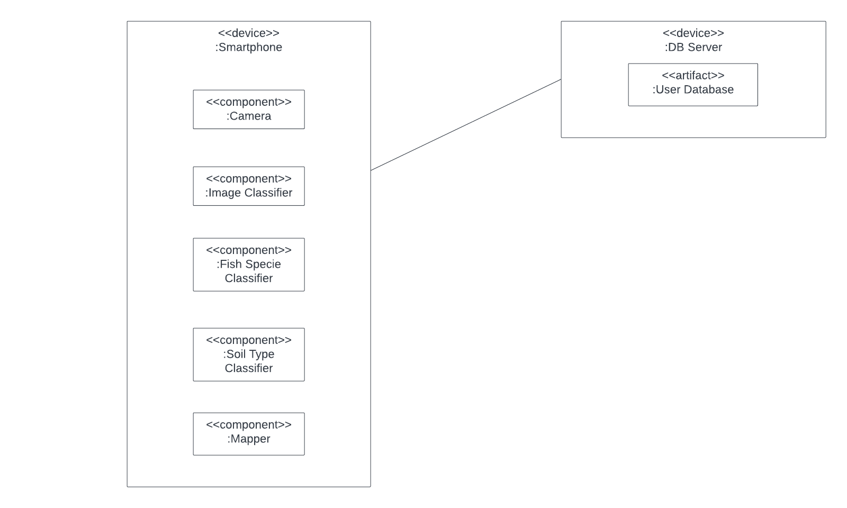

*Figure 1: Deployment Diagram*

## Software Architecture

The Component diagram showcases the essential building blocks of our application. It outlines the core components, including Mobile Application, AI Algorithms, and Database Integration. Each component is further dissected into key sub-components, such as Soil and Fish Classification Modules and Recommendation Systems (Mapper). This visual representation offers a concise overview of the modular structure and interdependencies within our intelligent sustainable AI-driven farming application.

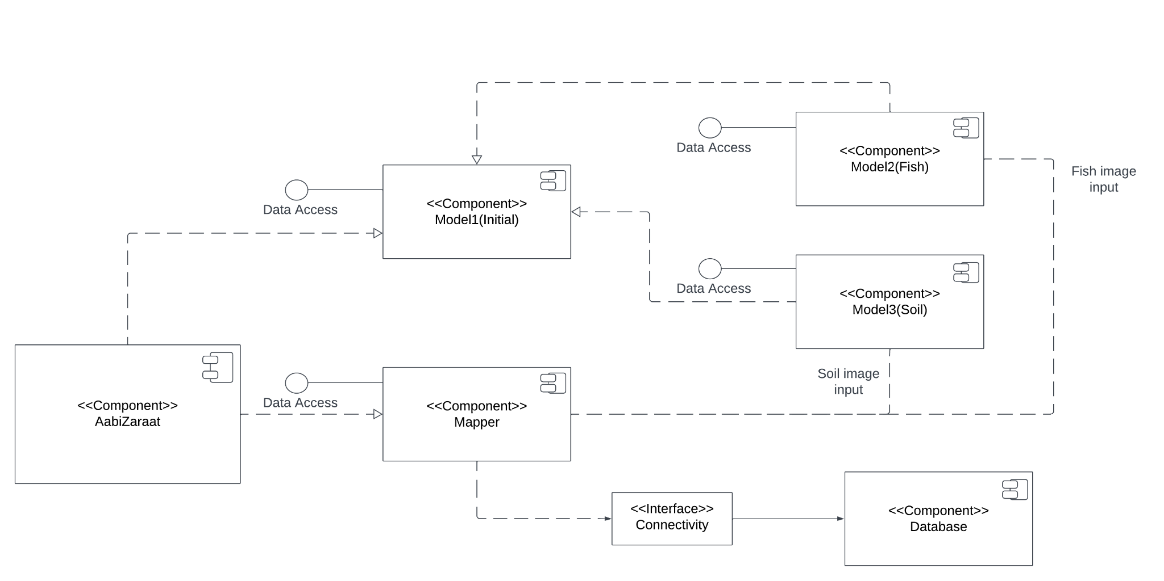

*Figure 2: Component Diagram*

# Design Strategy

**1. Future System Extension or Enhancement:**

* Design Decision: Employ a modular and scalable architecture to facilitate future system extensions or enhancements. Adopt a microservices approach to decouple components, allowing for independent development and updates. This strategy supports the integration of new features, such as additional soil types or expanded fish datasets, without causing extensive disruptions to the existing system.

**2. Safety Requirements:**

* User safety is paramount in the design of the mobile application. It must deliver accurate and reliable information for soil and fish classification to prevent any potential harm. Ensuring the precision of soil and fish data is crucial, with error handling mechanisms in place to provide clear and concise messages to users in the event of inaccuracies or failures. The application should also incorporate user-friendly guidance and instructions, enhancing the overall safety and usability of the platform.

**3. User Interface Paradigms:**

* Design Decision: Prioritize an intuitive and user-friendly interface to enhance user experience. Employ a responsive design that adapts to various screen sizes and resolutions, ensuring accessibility for a broad range of devices. Utilize established design principles to provide a consistent and visually appealing user interface, promoting ease of use and understanding for both farmers and inspectors.

**4. Data Management (Storage, Distribution, Persistence):**

* Design Decision: Implement a hybrid data management strategy that combines cloud-based storage for scalability and on-device storage for offline functionality. Utilize a relational database for structured data (e.g., user profiles), and a NoSQL database for efficient storage and retrieval of unstructured data, such as images and AI model results. This approach balances performance, scalability, and data integrity.

**5. Concurrency and Synchronization:**

* Design Decision: Adopt an asynchronous and event-driven architecture to manage concurrency efficiently. Leverage message queues and event-driven paradigms to handle parallel processing of soil and fish identification tasks. Integrate synchronization mechanisms to ensure consistency in data updates and prevent conflicts, especially when multiple users are interacting with the system simultaneously.

## Database Design

### ER Diagram

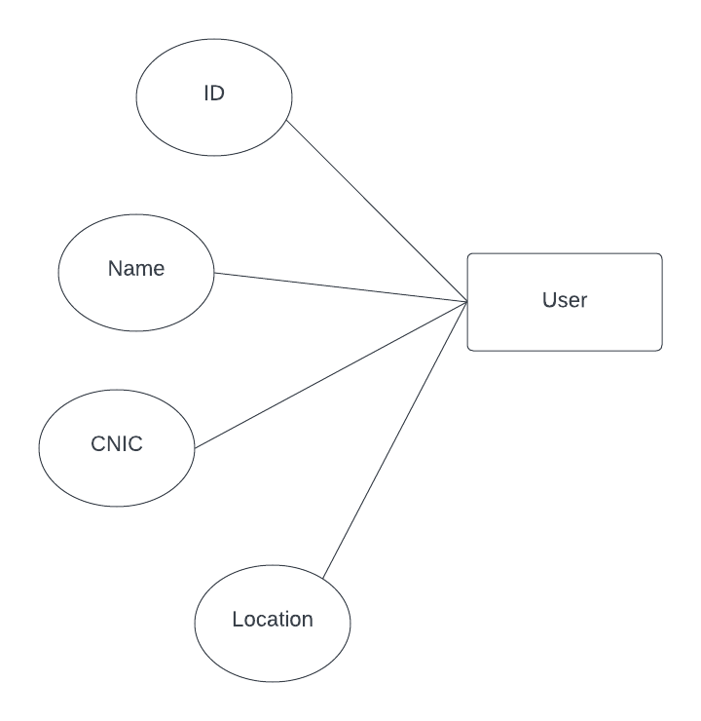

*Figure 3: ER Diagram*

### Data Dictionary

|  |  |  |  |  |  |  |  |
| --- | --- | --- | --- | --- | --- | --- | --- |
| **User** | | | | | | | |
| **Name** | | User | | | | | |
| **Alias** | |  | | | | | |
| **Where-used/how- used** | | Used to store user information. | | | | | |
| **Content description** | | User | | | | | |
|  | | | | | | | |
| **Column Name** | **Description** | | **Type** | **Length** | **Null able** | **Default Value** | **Key Type** |
| *ID* | *Unique ID of user* | | *String* |  | *No* |  | *PK* |
| *Name* | *Name of the user* | | *String* |  | *No* |  |  |
| *CNIC* | *Registered CNIC number of the user* | | *String* |  | *No* |  |  |
| *Location* | *Current location of the user* | | *String* |  | *Yes* |  |  |

#### Data

***5.2 Application Design***

### Sequence Diagram

#### <Sequence Diagram 1>

The Sequence diagram captures the dynamic interactions within our application, illustrating the chronological flow of activities. It commences with user interactions, triggering processes like image capture through the camera, which then engage the Image Processing and AI Inference components. The sequence seamlessly integrates with the Database, querying for relevant information on soil, fish, and agricultural practices. Finally, the Recommendation System processes this data, providing user-friendly outputs and insightful guidance. This diagram serves as a visual narrative, depicting the synchronized dance of components in our innovative farming companion.

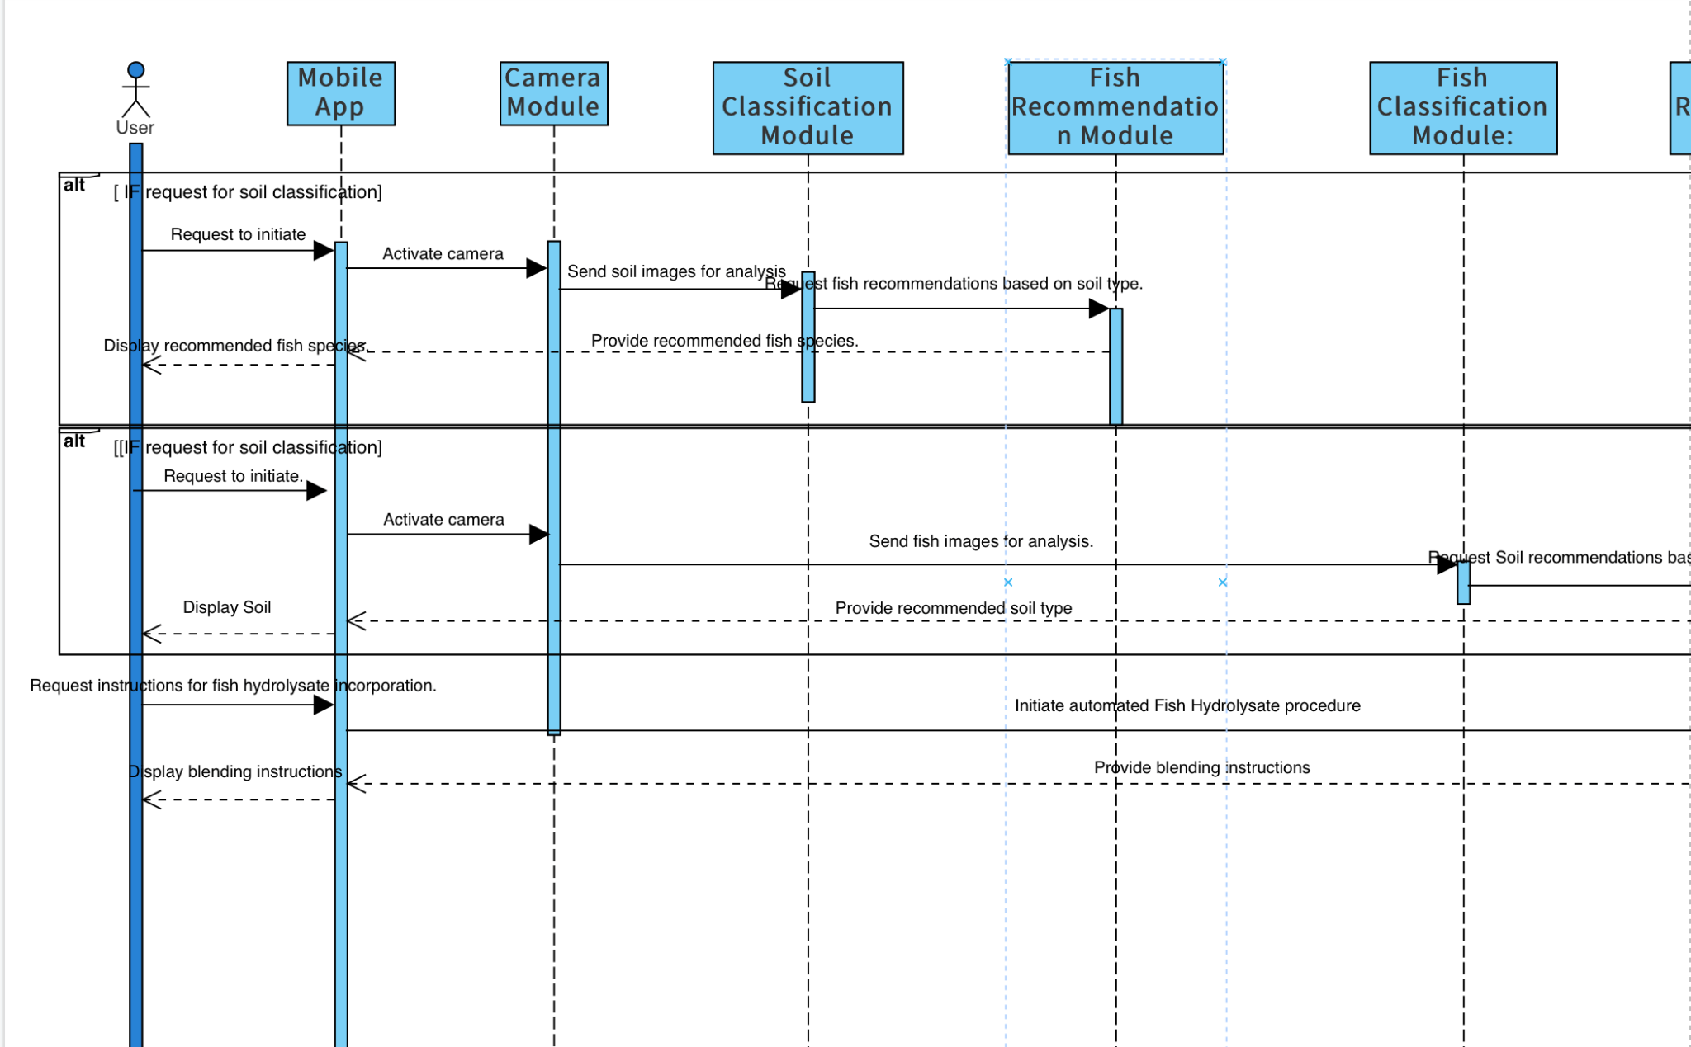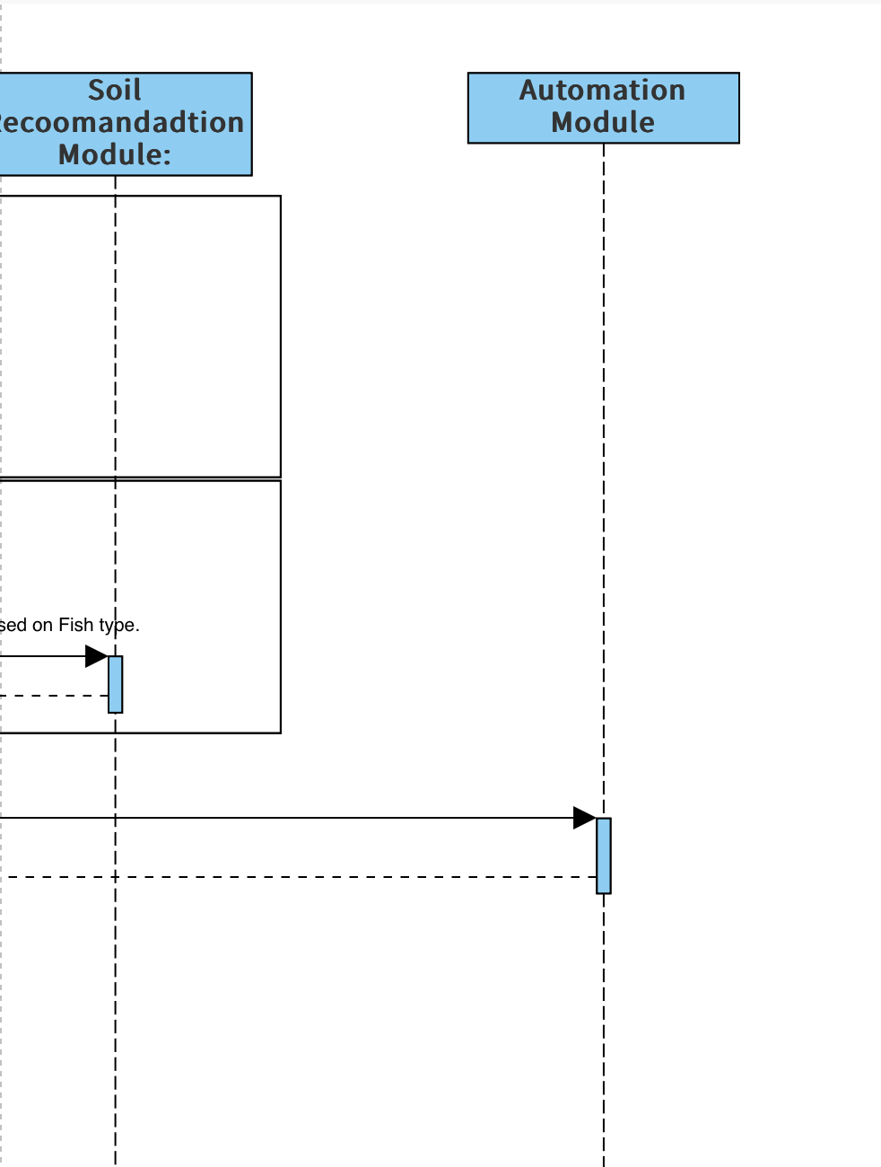

*Figure 4: Sequence Diagram*

### State Diagram

#### <State Diagram 1>

The State diagram encapsulates the various states our application can traverse, offering a snapshot of its behavior in response to different stimuli. It starts in an initial state, awaiting user input. Upon capturing an image, it transitions to the Image Processing state, followed by the AI Inference state for classification. Depending on the outcome, it diverges into states like Soil Classification, Fish Classification, or an Error state for invalid inputs. The process converges into the Recommendation Display state, delivering valuable insights. This State diagram visualizes the dynamic journey our application undertakes, adapting to diverse scenarios for an optimal user experience.

*Figure 5: State Machine Diagram*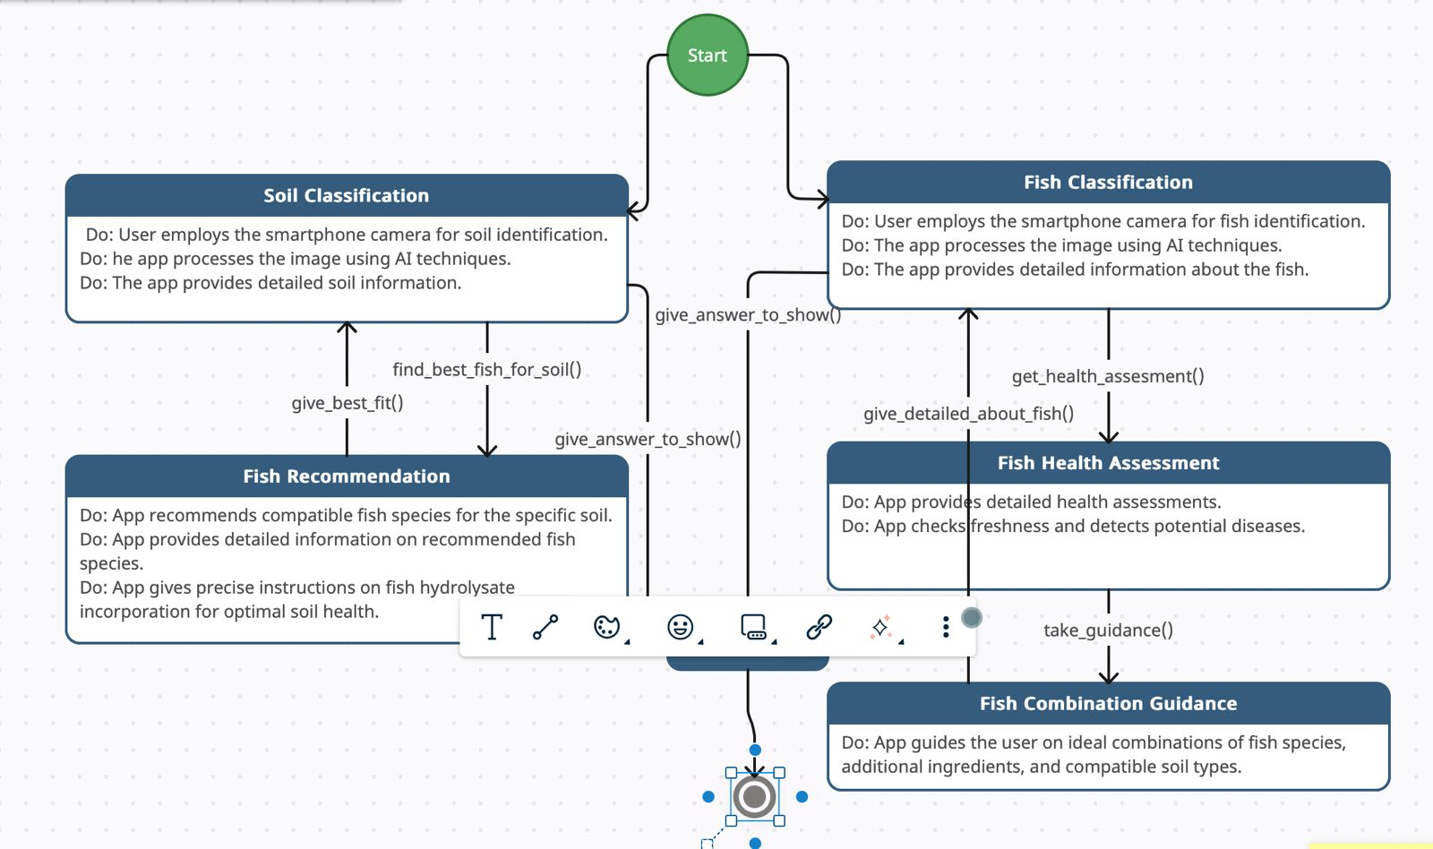

**6. References**

*[1] A. Holzinger et al., "Current Advances, Trends and Challenges of Machine Learning and Knowledge*

*Extraction: From Machine Learning to Explainable AI," in Machine Learning and Knowledge Extraction,*

*Springer, Cham, 2018, pp. 1, DOI: 10.1007/978-3-319-99740-7_1.*

*[2] M. Hassaballah and K. M. Hosny (Eds.), "Recent Advances in Computer Vision: Theories and*

*Applications," Studies in Computational Intelligence, Springer Cham, 2019, pp. XV, 425,*

*DOI:10.1007/978-3-030-03000-1.*

*[3] A. A. Khan, A. A. Laghari, S. A. Awan, "Machine Learning in Computer Vision: A Review," SIS*

*EAI,2021, DOI: 10.4108/eai.21-4-2021.169418.*

*[4] Government of Pakistan, Ministry of Finance, "Pakistan Economic Survey 2020-21," 2021. [Online].*

*Available: https://www.finance.gov.pk/survey/chapters_21/02-Agriculture.pdf.*

*[5] M. A. Khan and M. Ahmed, "Review of Available Knowledge on Land Degradation in Pakistan,"*

*ICARDA, March 2012.*

*[6] "The Impact of Fertilizers on the Environment: Inorganic vs. Organic," Farmerline, June 23, 2023.*

*Available: https://farmerline.co/*

*[7] Nation, "Unsustainable farming," The Nation, Jul. 4, 2023. [Online]. Available:*

*https://www.nation.com.pk/04-Jul-2023/unsustainable-farming*

*[8] IIPS. (2023). "Sustainable Agriculture and Food Security: Boosting Pakistan's Economy." [Online].*

*Available: https://iips.com.pk/sustainable-agriculture-and-food-security-boosting-pakistans-*

*economy/#:~:text=Soil%20erosion%2C%20salinity%2C%20and%20declining,its%20ability%20to%20su*

*pport%20crops*

*[9] H. N. Pahalvi, L. Rafiya, S. Rashid, B. Nisar, and A. N. Kamili, "Chemical Fertilizers and Their Impact*

*on Soil Health," in: First Online: 01 April 2021. DOI: 10.1007/978-3-030-61010-4_1. Available:*

*https://link.springer.com/chapter/10.1007/978-3-030-61010-4_1*

*[10] M. A. Khaskheli, "Fertilizers and Environmental Pollution," Agriculture Officer Sanghar. [Online].*

*Available: https://www.pakissan.com/english/issues/fertilizers.and.environmental.pollution.shtml*

*[11] M. A. Khaskheli, "Fertilizers and Environmental Pollution," Agriculture Officer Sanghar. [Online].*

*Available: https://www.pakissan.com/english/issues/fertilizers.and.environmental.pollution.shtml*

*[12] S. Z. H. Shah, H. T. Rauf, M. I. Ullah, M. S. Khalid, M. Farooq, M. Fatima, S. A. C. Bukhari, "Fish-*

*Pak: Fish species dataset from Pakistan for visual features based classification," Department of Zoology,University of Gujrat, Pakistan; Department of Computer Science, University of Gujrat, Pakistan;*

*Department of Fisheries and Aquaculture, University of Veterinary and Animal Sciences, Lahore,*

*Pakistan; Division of Computer Science, Mathematics and Science, Collins College of Professional*

*Studies, St. John's University, New York, USA.*

*[13] G. Wright, "AI is becoming an 'integral part' of fisheries management and seafood processing," Mar.*

*20, 2023.*

*[14] M. M. U. Rehman, "Advancements in Fish Farming is a Sustainable Solution for Future Fish*

*Demand," Jun. 22.*

*[15] M. Y. Laghari, "Aquaculture in Pakistan: Challenges and opportunities," Int. J. Fisheries Aquat.*

*Stud., vol. 6, no. 2, pp. 56-59, 2018.*

*[16] S. Abbas, S. Fatima, and M. S. Khattak, "The role of aquaculture in the sustainable development of*

*irrigated farming systems in Punjab, Pakistan," Published online: June 28, 2008. DOI: 10.1046/j.1365-*

*2109.1997.00912.x.*

*[17] I. Ahuja, E. Dauksas, J. F. Remme, R. Richardsen, and A.‐K. Løes, "Fish and fish waste-based*

*fertilizers in organic farming – With status in Norway: A review," Norwegian Centre for Organic*

*Agriculture (NORSØK), Tingvoll, Norway; Department of Biological Sciences, Norwegian University of*

*Science and Technology (NTNU), Ålesund, Norway; SINTEF Ocean, Ålesund, Norway; SINTEF Ocean,*

*Tromsø, Norway, Received May 22, 2020, Revised July 8, 2020, Accepted July 28, 2020, Available*

*online July 28, 2020. DOI: 10.1016/j.wasman.2020.07.025.*

*[18] "AnchoisFert: A New Organic Fertilizer from Fish Processing Waste for Sustainable Agriculture,"*

*Published online: March 2, 2022. DOI: 10.1002/gch2.202100141.*

*[19] M. Radziemska, M. D. Vaverková, D. Adamcová, M. Brtnický, and Z. Mazur, "Valorization of Fish*

*Waste Compost as a Fertilizer for Agricultural Use," Original Paper, Published: April 16, 2018, vol. 10,*

*pp. 2537-2545, 2019.*

*[20] M. Khan and C. A. Damalas, "Farmers' knowledge about common pests and pesticide safety in*

*conventional cotton production in Pakistan," Published online: July 14, 2015. DOI:*

*10.1016/j.cropro.2015.07.014.*

*[21] F. Aldosari, M. Mubushar, and M. B. Baig, "Assessment of farmers knowledge on pesticides and*

*trainings on pesticide waste management in Central Punjab – Pakistan," Journal of Experimental Biology*

*and Agricultural Sciences, vol. 6, no. 1, pp. 168-175, February 2018. DOI: 10.18006/2018.6(1).168.175.*

*[22] M. F. Ali, M. Ashfaq, S. Hassan, and R. Ullah, "Assessing Indigenous Knowledge through Farmers’*

*Perception and Adaptation to Climate Change in Pakistan," Institute of Agricultural and Resource*

*Economics, University of Agriculture, Faisalabad, Pakistan. Received: August 3, 2017; Accepted:*

*February 10, 2018.*

*[23] S. Fahad, T. Inayat, J. Wang, L. Dong, G. Hu, S. Khan, and A. Khan, "Farmers’ awareness level and*

*their perceptions of climate change: A case of Khyber Pakhtunkhwa province, Pakistan," Published*

*online: 2020. DOI: 10.1016/j.landusepol.2020.104669.*

*[24] A. Memon, "Agriculture: The need to increase farmers’ knowledge," Published: March 20, 2023.*

**Appendices**

*[Refer To Literature Review Document]*